***Fujinomiya Bulletin***

***November ２０２4***

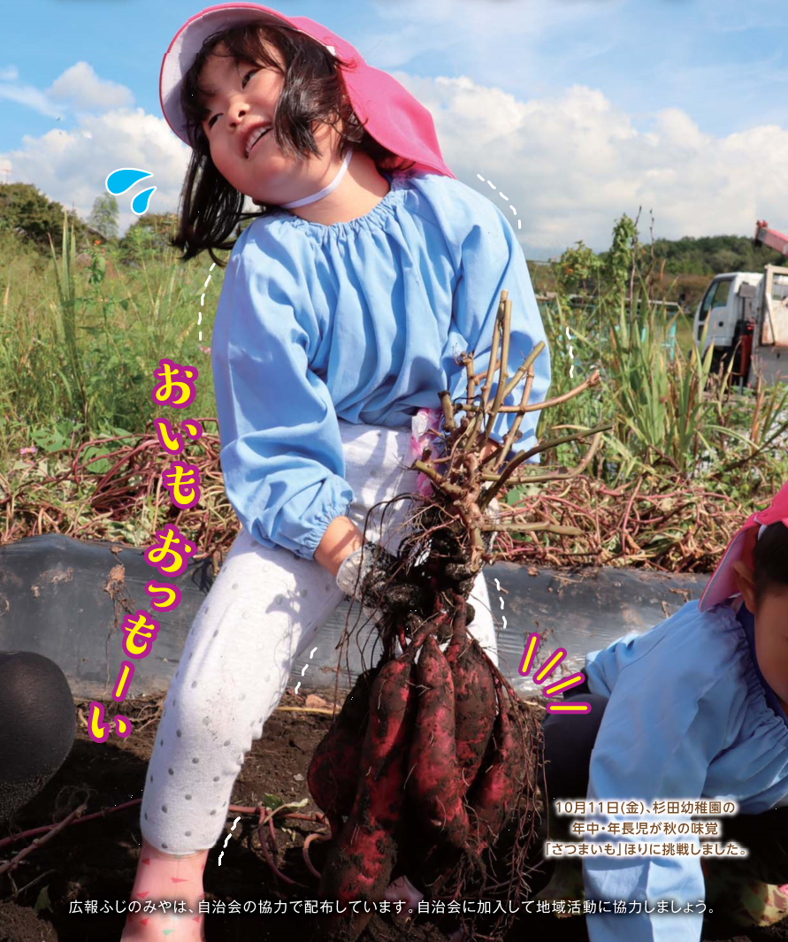

**Have you already paid your taxes?**

**Inquiry Tax & Premium Collection Division *(Shuno-ka)***

**☎ 0544-22-1129 FAX 0544-22-1227**

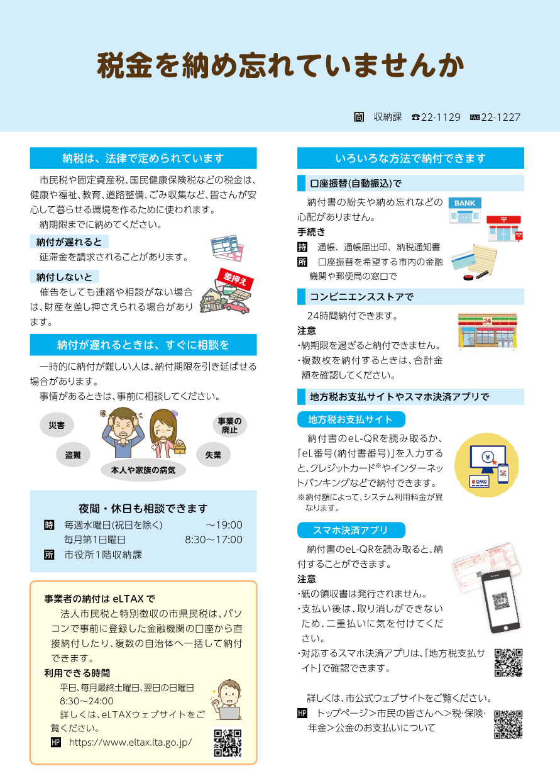



**Payment can be made in various ways.**

**Tax payments must be made by law.**



**By Direct Debit (automatic transfer)**

**(automatic transfer)**

Municipal resident tax, property tax, national health insurance tax, and other taxes are used to create a safe and comfortable environment for everyone, including health, welfare, education, road maintenance, and garbage collection service.

**Please pay them by the due date.**

It's safe and convenient, as you don't have to worry about losing your payment slip or forgetting to pay.

**Process**

**What to bring** Bankbook, Bankbook seal,

Notice of tax payment

**Place** At a bank or post office in the city in which you wish to direct debit.





**If your payment is delayed...**

You will be charged a late fee.

**If you don't pay...**



If you fail to pay your tax and do not contact or consult with us even after a notice, your property may be seized.

**At convenience stores**

**(automatic transfer)**

**SEIZED**



Payment can be made 24 hours a day.

**Caution**

・You cannot pay after the due date.

・When making multiple payments at once, please check the total amount.

**Holidays and nighttime**

**OK**

**If you cannot pay by the due date, contact us. immediately!**

If you have special circumstances or cannot pay by the due date, please consult with us as soon as possible.

**"Local Tax Payment Site"/ Smart Phone Payment Apps**

**(automatic transfer)**



**"Local Tax Payment Site"**

**(automatic transfer)**



**Disaster**

**Going out of business**

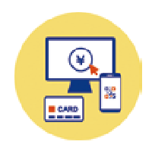

Payment can be made by scanning the el-QR on the payment slip.

By scanning the el-QR on the payment slip or entering the "el number (payment slip number)", you can pay by credit card or Internet banking.

※The system usage fee will be charged.

**Unemployment**



**Illness of you or your family**



**Evenings and holidays are also available for consultation.**

**When** Every Wednesday (excluding holidays) -19:00

The 1st Sunday of every month 8:30-17:00

**Place** Tax & Premium Collection Division,

1st floor of City Hall



**Smart Phone Payment Apps**

**(automatic transfer)**

Payment can be made by scanning the el-QR on the payment slip.

**Caution**

・Paper receipts will not be issued.

・Once payment has been made, it cannot be cancelled, so please be careful not to make a double payment.

・You can find the available smartphone payment apps on the "Local Tax Payment Site".

For more information, please visit the city's official Web site.

**HP** トップページ>市民の皆さんへ>税・保険・年金>公金のお支払いについて

**"eLTAX" for business owners**

Corporate municipal resident tax and special municipal and prefectural resident taxes can be paid directly from a financial institution's account via the internet, and can be paid to multiple municipalities at once.

**Available Hours**

8:30-24:00

- Weekdays

- The last Saturday of the month

and the following Sunday

For more information, please visit the eLTAX website.

**HP** https://www.eltax.lta.go.jp/

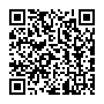



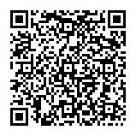



Information on Pregnancy, Children, Childcare

|  |
| --- |
| **If your child get sick suddenly** |
| **Inquiry** Shizuoka Child Emergency Telephone Consultation *(Shizuoka kodomo kyukyu denwa sodan)*  **☎#8000　or 054-247-9910**  **Time** Available 24 hours a day  ※In case of **emergency,** do not hesitate to call **☎119** |

|  |
| --- |
| **Counseling for children** |
| **Inquiry** Family and Child Counseling Section, Children's Future Division  *(kodomo mirai-ka, katei jido sodan-kakari)* **☎0544-22-1230**  **Time** Weekdays 8:30～17:15    **Inquiry** Child Guidance Center *(Jido sodan jo)*  **For consultation only: ☎0120-189-783**  **Time** Available 24 hours a day |

|  |
| --- |
| **Counseling on abuse** |
| **Inquiry** Child Guidance Center *(Jido sodan jo)*  **For abuse only: ☎189**  **Time** Available 24 hours a day |

|  |
| --- |
| **Counseling on bullying, truancy, attitude toward life, and employment** |
| **Inquiry** Youth Counseling Center *(Seishonen sodan center)*  Elementary and Junior high school students: **☎0544-22-0064**  Junior high school students - 39 years old: **☎0544-22-1252**  E-mail Counseling : **e-sodan@city.fujinomiya.lg.jp**  **Time** Weekdays 9:00～17:00 (Until 19:30 on the 2nd and 4th Wednesday of each month) |

|  |  |  |  |  |
| --- | --- | --- | --- | --- |
|  | Male | Female | Total | Household |
| Population | 63,190 | 63,965 | 127,155 | 59,290 |
| Month to month basis | (-61) | (-67) | (-128) | (-23) |

**The number of population and households**  (As of October 1st, 2024)

|  |  |
| --- | --- |
| **Notice** | **Welfare Loan Program for single-parent families** |
| The prefectural government provides interest-free loans to single-parent families whose children are enrolling in high school, university, or vocational school.  The loan limit varies depending on the type of school, public or private school and the conditions of commuting, etc.    **■School fees**  Tuition, Commuting fees, etc.  **■Enrollment fee, etc.**  Preparation fee to enroll in high school, university, or vocational school  **Eligibility** -Children from single-parent families -Children under 20 years old without parents  **Application** From November 1 (Fri), Application forms will be available and accepted at the counter of the Children's Future Division on the 1st floor of City Hall.  **Others** Interviews will be held at a later date. This loan program cannot be provided to students who are using a scholarship program such as "IKUEIKAI", etc.  **Inquiry** Children's Future Division *(Kodomo Mirai-ka)* ☎0544-22-1146 | |



The Japanese fiscal year begins in April and ends in March.

Example:

FY2024 (from April 2024 to March 2025)

FY2025 (from April 2025 to March 2026)

Information on Seniors, Health, Medical Care, Nursing Care, and Disabilities

|  |  |
| --- | --- |
| **Notice** | **For those turning 70 (National Health Insurance members) and 75 years old**  **Health Insurance Card will be changed.** |
| New health insurance cards will not be issued from December 2 (Mon).  If you meet one of the following conditions, we will send the “Eligibility Confirmation Letter,” which will be used instead of your health insurance card, by the expiration date.  -Those who will turn 75 years old from December 2 (Mon) to July 31 (Thu), 2025.  -Those who will turn 70 years old from December 2 (Mon) to July 31 (Thu), 2025, and do not have a MYNA insurance card (My Number Card registered to be used as a health insurance card).  ※If you do not meet the above conditions and would like to obtain the “Eligibility Confirmation Letter”, please contact us.  ※Your health insurance card can be used until its expiration date.  **Advantages of using “MYNA insurance card”**    **Doctors and pharmacists can correctly know information about previously prescribed medicines and the results of medical checkups.**  **Payment in excess of the maximum amount can be exempted without submitting the Certificate of Eligibility for the Maximum Amount.**  **How can be used “MAINA Insurance Card”**  ①Make your “My Number Card”.  Application procedures can be found on the city's official website.    **HP** トップページ>市民の皆さんへ>登録・証明>マイナンバー>マイナンバーカードの申請方法  ②Register your “My Number Card” as a health insurance card.  ■By computer or smartphone  -MYNA Portal Site  ■In the City  -Seven Bank ATMs  - Medical institutions, Pharmacies  **HP** トップページ>市民の皆さんへ>登録・証明>マイナンバー>マイナンバーカードの保険証としての利用申込み  **Inquiry** Insurance and Pension Division *(Hoken Nenkin-ka)*  ☎0544-22-1138 | |

Information on Events, Applications, Notices, National Insurance, Pensions, Subsidies, Aids, Businesses

|  |  |
| --- | --- |
| **Recruitment** | **Potluck Party "Let's chat in English!"** |
| Bring one dish and enjoy communicating with foreign people.  **When** December 7 (Sat), 18:00-20:00  **Place** Exchange Center "*Ekimae Koryu Center KIRARA*"  **Maximum no.** 80 people (first-come-first-served basis)  **Fee** 500 yen (free for foreign people and FAIR members)  **Application** From November 15 (Fri) to 28 (Thu)  Please send us an e-mail or visit the FAIR's office with your ①address, ②name, ③ age, ④phone number, ⑤nationality.  **Inquiry** Fujinomiya Association for International Relations "FAIR" *(Fujinomiya Kokusai Koryu Kyokai)*  (Located in Ekimae Koryu Center KIRARA)  ☎0544-22-8111  E-mail: [info@fair-fujinomiya.com](mailto:info@fair-fujinomiya.com) | |

|  |  |
| --- | --- |
| **Notice** | **There is a large outbreak of millipedes (Yanbaru-Tosaka-Yasude).** |
| **What is Yanbaru-Tosaka-Yasude?**  It prefers moist grassland, soil with many fallen leaves, gutters, and other damp areas with little sunlight. It does not cause damage to crops or people, but once established, it is difficult to exterminate because of its high reproductive ability.    **To prevent mass outbreak of millipedes…**  -Weed and clean gutters to get more sunlight  -Put curing tape or other slippery material on house walls  -Use chemicals  **We are distributing pest control chemicals.**  **Application** Ward leaders submit the application form (available on the city's official website) by mail, fax, e-mail, online application or at the counter of Environmental Planning Division.  **Inquiry** Environmental Planning Division *(Kankyo Kikaku-ka)*  Tel: 0544-22-1136 Fax: 0544-22-1207  E-mail: kankikaku@city.fujinomiya.lg.jp  **HP** トップページ＞市民の皆さんへ＞まちづくり・景観＞環境＞衛生害虫駆除薬剤の申請について | |

|  |  |
| --- | --- |
| **Notice** | **Be aware of Bears!** |
| **Bears are coming out in the city.**  Please notify us immediately if you see one.    **If you encounter a bear**  - No shouting  - No eye contact  - No approaching  - Don't show your back and back away quietly.  **To keep bears away and avoid getting close to them**  - Don’t leave food waste outside.  - Make a sound with something.  - Cut down fruit trees which are not harvested.  - Check the city's official website for information on bear sightings.  **Inquiry** Flower, Green and Water Division *(Hana to Midori to Mizu no-ka)* ☎0544-22-1169    **HP** トップページ>市民の皆さんへ>住まい・ペット・動物>動物 | |

|  |  |
| --- | --- |
| **National Pension** | **Deduction Certificate for Social Insurance Premiums (National Pension Insurance Premiums)** |
| The Japan Pension Service will mail the "Deduction Certificate for Social Insurance Premiums (National Pension Insurance Premiums)" to those who have paid National Pension Insurance premiums from January to September 2024.  Please keep it in a safe place as you need it for your year-end tax adjustment or tax return.  **Others**  -If you have paid National Pension Insurance Premiums for youy family members, you can add them to your Social Insurance Premiums for a deduction.  -Those who paid National Pension Insurance premiums for the first time between October and December of this year will receive the deduction certificate in February.  **Inquiry**  - Dial for Pension System Members ☎ 0570-003-004  - If you make a call from a phone that begins with 050, please dial ☎ 03-6630-2525  - Fuji Pension Office *(Fuji nenkin jimusho)* ☎ 0545-61-1900 | |

**Schedule from November 1st to December 10th**



**■First–aid Medical Treatment Center *(Kyukyu Iryo Center)***

**☎0544-24-9999 / Fax: 0544-24-9995 /** **Address: 12-1 Miyahara, Fujinomiya, Zip Code 418-0005**

|  |  |  |
| --- | --- | --- |
| **Medical treatment subject** | **Day** | **Time** |
| **Internal medicine (*Naika*), Pediatrics (*Shonika*), Surgery (*Geka*)** | Weekdays | 19:00-8:00 on the next day |
| Saturdays | 14:00-8:00 on the next day |
| Sundays, Public holidays,  Year–end and New year holidays | 8:00-8:00 on the next day |
| **Dentistry (*Shika*)** | Sundays, Public holidays,  Year–end and New year holidays | 9:00-17:00  *Reception: until 16:30 |

*If your condition is severe, dial **119** for ambulance. Make sure to bring your **health insurance card** with you.

**■Emergency Ophthalmological Clinics *(Ganka)*** **Open: 9:00-17:00**

*Please make sure to contact the clinics beforehand as they may change.

|  |  |  |
| --- | --- | --- |
| **Date** | **Clinics name/ Address** | **Tel** |
| November 3 | Yamamoto Ganka Clinic/ Ishizaka Fuji city | 0545-21-0069 |
| November 4 | Kato Iin/ Hina Fuji city | 0545-34-0011 |
| November 10 | Tenjin Ganka Iin/ Wakanomiya-cho | 0544-23-7050 |
| November 17 | Komori Ganka Clinic/ Denbo Fuji city | 0545-21-0333 |
| November 23 | Nakajima Ganka/ Iriyamase Fuji city | 0545-72-0011 |
| November 24 | Unno Ganka Iin/ Matsuoka Fuji city | 0545-30-6260 |
| December 1 | Saito Ganka Iin/ Nishikoizumi-cho | 0544-28-5615 |
| December 8 | Toda Ganka Iin/ Miyahara | 0544-21-9666 |

**■Emergency Obstetrics and Gynecology Clinics *(Sanfujinka)* Open: 9:00-24:00**

*Please make sure to contact the clinics beforehand as they may change.

|  |  |  |
| --- | --- | --- |
| **Date** | **Clinics name/ Address** | **Tel** |
| November 3 | Fujinomiya City General Hospital/ Nishiki-cho | 0544-27-3151 |
| November 10 | Tenjin Sanfujinka Iin/ Wakanomiya-cho | 0544-24-1322 |
| November 17 | Bando Ladies Clinic/ Sugita | 0544-28-5800 |
| November 24 | Otabe Sanfujinka Iin/ Hibarigaoka | 0544-23-1182 |
| December 1 | Fujinomiya City General Hospital/ Nishiki-cho | 0544-27-3151 |
| December 8 | Bando Ladies Clinic/ Sugita | 0544-28-5800 |

**■Blood Donation**

|  |  |  |
| --- | --- | --- |
| **Date** | **Clinics name/ Address** | **Time** |
| November 9 | AEON Mall Fujinomiya/ Asama-cho | 9:30–16:00* |
| November 17 | AEON Mall Fujinomiya/ Asama-cho | 9:30–16:00* |
| November 19 | City Hall/ Yumizawa-cho | 9:00–16:00* |
| November 24 | AEON Mall Fujinomiya/ Asama-cho | 9:30–16:00* |

* Not implemented from 12:00-13:15

**Inquiry** Welfare Planning Division *(Fukushi Kikaku-ka)* **☎** 0544-22-1457

■**Due Dates for tax or other payments**

|  |  |
| --- | --- |
| **Date** | **Taxes to be payed** |
| November 5 | Municipal and prefectural resident tax (3rd term) |
| Natinal Health Insurance Tax (4th term) |
| Long Term Care Insurance Premium (4th term) |
| November 28 | Water charges and Sewerage charges (for October usage) |
| December 2 | Medical Insurance Premium for the elderly (4th term) |
| Contribution for public sewerage system (3rd term) |
| Child care fee (for November usage) |
| Public housing fee / Parking fee (for November usage) |
| December 3 | Natinal Health Insurance Tax (5th term) |
| Long Term Care Insurance Premium (5th term) |

**■Counseling and Consultation** *Not implemented on public holidays.

**〈Place: Citizen counselling room, 1st floor, City Hall〉**

|  |  |
| --- | --- |
| **Consultation** | **Date & Time** |
| 1. General counseling　*(Ippan sodan)* 2. Counseling for non-Japanese residents　*(Gaikokujin sodan)* | Monday-Friday 8:30-17:00  (*Reception: until 16:30) |
| 1. Counseling on consumer affairs　*(Shohi seikatsu sodan)* | Monday-Friday 9:00-16:00 |
| ④ Attorney　*(Bengoshi sodan)*  *Appointment is required (by 12:00 the day before the consulting day, seats are limited to the first 7 people) | November 6, 13, 20, 27  (13:30- until the end of the consultation) |
| ⑤ Judicial scrivener *(Shihosyoshi sodan)*  *Appointment is required | November 8 13:00-16:00 |
| 1. Licensed tax accountant *(Zeirishi zeimu sodan)*   *Appointment is required | November 5, 19 13:00-15:00 |
| 1. Administrative scrivener *(Gyosei syoshi sodan)* | Not implemented for this month |
| 1. General administrative counseling *(Gyosei sodan)* | November 14 10:00-15:00 |
| 1. Consultation on the human rights *(Jinken sodan)* | November 19 13:00-16:00 |
| 1. Consultation on side jobs *(Naisyoku assen)* | Mondays and Thursdays 9:00-16:00 |
| 1. Patent attorney　*(Benrishi sodan)* *Appointment is required. | November 22 15:00-17:00 |
| 1. Business start-up consultation *(Sogyo sodan)*   *Appointment is required. | November 26 10:00-15:00 |

①,③-⑨ Community Service Division *(Shimin Seikatsu-ka)*

② Citizen Exchange Division *(Shimin Koryu-ka)*

⑩-⑫ Commerce and Industry Division *(Syoko Shinko-ka)*

**☎** 0544-22-1196

**☎** 0544-22-1246

**☎** 0544-22-1295

**Inquiry**

**〈Place: Meeting Room 510, 5th Floor, City Hall〉**

|  |  |
| --- | --- |
| **Consultation** | **Date & Time** |
| Real estate transaction agent *(Takuchi tatemono torihikishi sodan)* | November 12 13:00-15:00 |

**Inquiry** Construction and Housing Division *(Kenchiku Jyutaku-ka)* **☎** 0544-22-1163

**〈Place: Meeting Room 721, 7th Floor, City Hall〉**

|  |  |
| --- | --- |
| **Consultation** | **Date & Time** |
| Pension consultation *(Nenkin sodan)* *Appointment is required. | November 28 10:00-15:00 |

**Inquiry** Fuji Pension Office in Fuji city*（Fuji Nenkin Jimusho）* **☎** 0545-61-1900



**富士宮市**

FUJINOMIYA　CITY

■**City Hall Open Days on Holidays:** We open on the first Sunday of each month.

**November 3 (Sun)**

**December 1 (Sun)**

**8:30-17:00**

|  |  |
| --- | --- |
| **Division & Phone number** | **Services** |
| Citizen Registration Division  *(Shimin-ka)*  **☎** 0544-22-1134〈Certification and My Number Card〉  **☎** 0544-22-1135〈Family Register and Address〉 | * Submission for Family Register *(koseki)* (birth, marriage, death, etc.) * Submission of change of residence (moving into the city, moving out of the city, moving within the city, etc.) * Application for seal *(inkan)* registration and abolition * Issuance of various certificates (certificate of residence*(jyuminhyo)*, Family Register*(koseki tohon, koseki syohon)*, certificate of seal*(inkan)* registration) * Receiving passports * Procedures for applying for My Number Card     The services we handle are different from normal days. For details, please call or visit the city's official website. |
| Insurance and Pension Division  *(Hoken Nenkin-ka)*  **☎** 0544-22-1138 | * Qualification and disqualification for National Health Insurance |
| Child Future Division  *(Kodomo Mirai-ka)*  ☎ 0544-22-1146 | * Application for Child Allowance and Child Medical Expense Beneficiary Certificate |
| Tax & Premium Collection Division  *(Shuno-ka)*  ☎ 0544-22-1129〈Payment〉  ☎ 0544-22-1128〈Certification〉 | * Payment of city taxes, etc. and Consultation on payment * Issuance of tax certificates   ※Appointment is required in advance for tax consultation.  ※Tax exemption certificates, etc. that require a declaration cannot be issued |

■**After-hours service: Every Wednesday until 19:00pm**

*No services if a public holiday falls on a Wednesday.

|  |  |
| --- | --- |
| **Division & Phone number** | **Services** |
| Citizen Registration Division  *(Shimin-ka)*  **☎** 0544-22-1134 | * Application for seal *(inkan)* registration and abolition * Issuance of various certificates (certificate of residence*(jyuminhyo)*, family register*(koseki tohon, koseki syohon)*, certificate of seal*(inkan)* registration)     The services we handle are different from normal days. For details, please call or visit the city's official website. |
| Tax & Premium Collection Division  *(Shuno-ka)*  ☎ 0544-22-1129 | * Payment of city taxes, etc. and Consultation on payment * Issuance of tax certificates   ※Appointment is required in advance for tax consultation.  ※Tax exemption certificates, etc. that require a declaration cannot be issued |